Name: ABDUL GHAFFAR KALHORO

Registration # 194699

Class: BSCS_6C

3rd semester

Database Systems Lab-2

SOURCE CODE for all tasks SCHEMA:

CREATE schema institute;

CREATE TABLE IF NOT EXISTS institute.Student (

snum INTEGER primary key,

sname CHAR(30),

major CHAR(25),

level CHAR(2)

);

CREATE TABLE IF NOT EXISTS institute.Faculty (

fid INTEGER PRIMARY KEY,

fname CHAR(30),

deptid INTEGER

);

Create Table IF NOT EXISTS institute.Class (

cname char(40) primary key,

meets_at char(20),

room char(10),

fid integer,

FOREIGN KEY (fid) REFERENCES institute.Faculty(fid)

);

Create Table IF NOT EXISTS institute.Enrolled (

snum integer,

cname char(40),

primary key (snum,cname),

foreign key (snum) references Student(snum),

foreign key (cname) references Class(cname)

);

ALTER TABLE Student

ADD age integer;

ALTER TABLE Student MODIFY COLUMN

sname varchar(30);

ALTER TABLE Class MODIFY COLUMN

cname varchar(40);

ALTER TABLE Faculty MODIFY COLUMN

fname varchar(30);

ALTER TABLE Enrolled MODIFY COLUMN

cname varchar(40);

ALTER TABLE Faculty MODIFY deptid INTEGER NOT NULL;

SCREENSHOTs

OUTPUT for Class table:

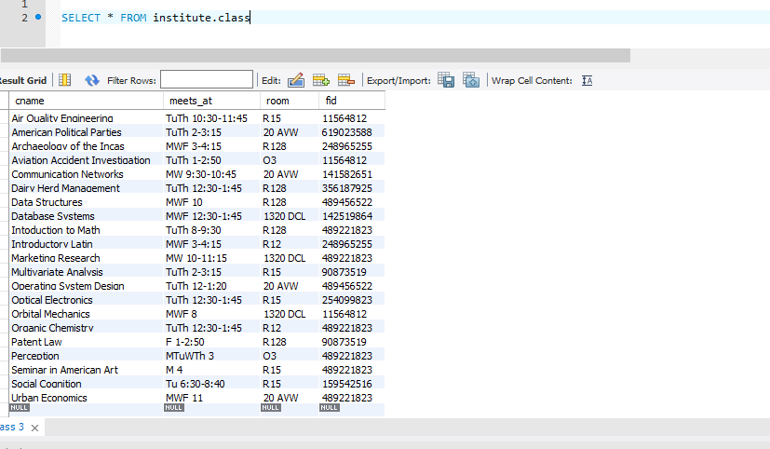

OUTPUT for Student table:

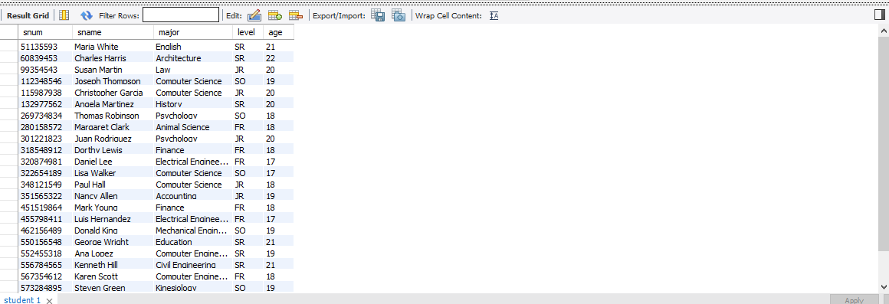

OUTPUT for Faculty table:

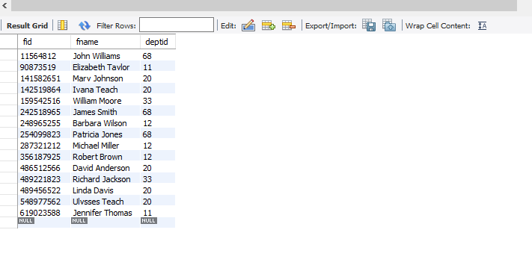

OUTPUT for enrolled table

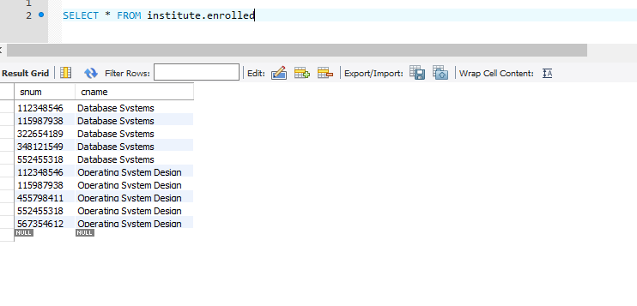

INSERTION OF DATA

INSERT INTO institute.Enrolled VALUES

(112348546,'Database Systems'),

(115987938,'Database Systems'),

(348121549,'Database Systems'),

(322654189,'Database Systems'),

(552455318,'Database Systems'),

(455798411,'Operating System Design'),

(552455318,'Operating System Design'),

(567354612,'Operating System Design'),

(112348546,'Operating System Design'),

(115987938,'Operating System Design')

COMMIT;

INSERT INTO institute.Student (snum,sname,major,level,age)

VALUES

(051135593,'Maria White','English','SR',21),

(060839453,'Charles Harris','Architecture','SR',22),

(099354543,'Susan Martin','Law','JR',20),

(112348546,'Joseph Thompson','Computer Science','SO',19),

(115987938,'Christopher Garcia','Computer Science','JR',20),

(132977562,'Angela Martinez','History','SR',20),

(269734834,'Thomas Robinson','Psychology','SO',18),

(280158572,'Margaret Clark','Animal Science','FR',18),

(301221823,'Juan Rodriguez','Psychology','JR',20),

(318548912,'Dorthy Lewis','Finance','FR',18),

(320874981,'Daniel Lee','Electrical Engineering','FR',17),

(322654189,'Lisa Walker','Computer Science','SO',17),

(348121549,'Paul Hall','Computer Science','JR',18),

(351565322,'Nancy Allen','Accounting','JR',19),

(451519864,'Mark Young','Finance','FR',18),

(455798411,'Luis Hernandez','Electrical Engineering','FR',17),

(462156489,'Donald King','Mechanical Engineering','SO',19),

(550156548,'George Wright','Education','SR',21),

(552455318,'Ana Lopez','Computer Engineering','SR',19),

(556784565,'Kenneth Hill','Civil Engineering','SR',21),

(567354612,'Karen Scott','Computer Engineering','FR',18),

(573284895,'Steven Green','Kinesiology','SO',19),

(574489456,'Betty Adams','Economics','JR',20),

(578875478,'Edward Baker','Veterinary Medicine','SR',21);

INSERT INTO institute.Faculty VALUES

(142519864,'Ivana Teach',20),

(242518965,'James Smith',68),

(141582651,'Mary Johnson',20),

(011564812,'John Williams',68),

(254099823,'Patricia Jones',68),

(356187925,'Robert Brown',12),

(489456522,'Linda Davis',20),

(287321212,'Michael Miller',12),

(248965255,'Barbara Wilson',12),

(159542516,'William Moore',33),

(090873519,'Elizabeth Taylor',11),

(486512566,'David Anderson',20),

(619023588,'Jennifer Thomas',11),

(489221823,'Richard Jackson',33),

(548977562,'Ulysses Teach',20);

COMMIT;

INSERT INTO institute.Class VALUES

('Data Structures','MWF 10','R128',489456522),

('Database Systems','MWF 12:30-1:45','1320 DCL',142519864),

('Operating System Design','TuTh 12-1:20','20 AVW',489456522),

('Archaeology of the Incas','MWF 3-4:15','R128',248965255),

('Aviation Accident Investigation','TuTh 1-2:50','Q3',011564812),

('Air Quality Engineering','TuTh 10:30-11:45','R15',011564812),

('Introductory Latin','MWF 3-4:15','R12',248965255),

('American Political Parties','TuTh 2-3:15','20 AVW',619023588),

('Social Cognition','Tu 6:30-8:40','R15',159542516),

('Perception','MTuWTh 3','Q3',489221823),

('Multivariate Analysis','TuTh 2-3:15','R15',090873519),

('Patent Law','F 1-2:50','R128',090873519),

('Urban Economics','MWF 11','20 AVW',489221823),

('Organic Chemistry','TuTh 12:30-1:45','R12',489221823),

('Marketing Research','MW 10-11:15','1320 DCL',489221823),

('Seminar in American Art','M 4','R15',489221823),

('Orbital Mechanics','MWF 8','1320 DCL',011564812),

('Dairy Herd Management','TuTh 12:30-1:45','R128',356187925),

('Communication Networks','MW 9:30-10:45','20 AVW',141582651),

('Optical Electronics','TuTh 12:30-1:45','R15',254099823),

('Intoduction to Math','TuTh 8-9:30','R128',489221823);

COMMIT;